Certification project. Devops -course (30th july - 22nd august 2018)

1.Using the Master VM for Jenkins, Ansible, Puppet, GIT etc.

2.Using the Clean Ubuntu VM image provided in the “Edureka Setup Guide” for Jenkins Slave Node (Test Server)

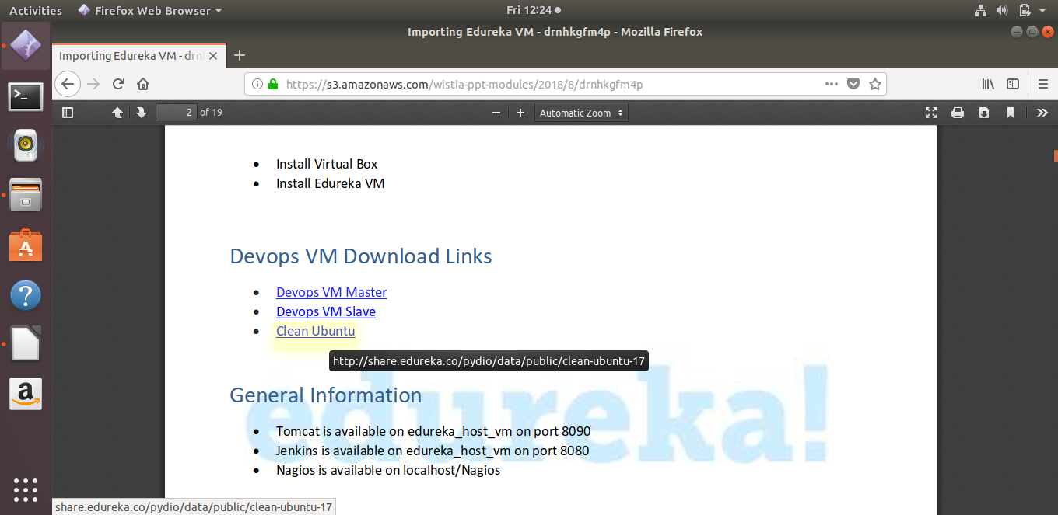

3.Change the IP address of the VMs accordingly

master vm ipaddress : - 192.168.56.101

for slave vm do the following:-

To configure IP please follow the below steps:

Open the VirtualBox and go to file on the left top and click on host network manager

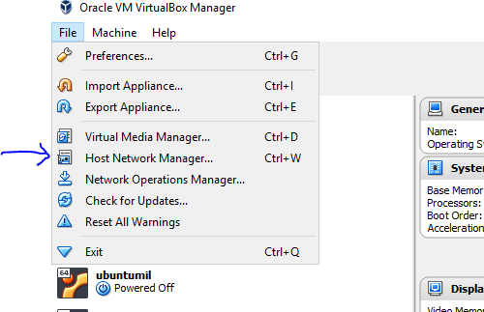

Click on DHCP server and make a note of lower address bound and upper address bound

Now open the virtual machine and in the terminal run the below command:
sudo su
nano /etc/network/interfaces

now edit the file with the following content

auto enpos8
iface enpos8 inet static
address IP_address

In place of IP_address specify an IP address between lower address bound and upper address bound.

i have set my slave node ipaddress to 192.168.56.102

NOTE: The IP address shown above is my IP you have to specify yours.

After making the changes save it and run the below command to restart the networking service:
systemctl restart networking

Once the networking restarts, restart the machine by running the below command:
reboot

4. Add Build Pipeline Plugin and Post-build task plugin to Jenkins on the master VM
- go to jenkins on localhost:8080
- go to Manage plugins and add the two plugins and other required plugins like (selenium,maven,etc) from available section.
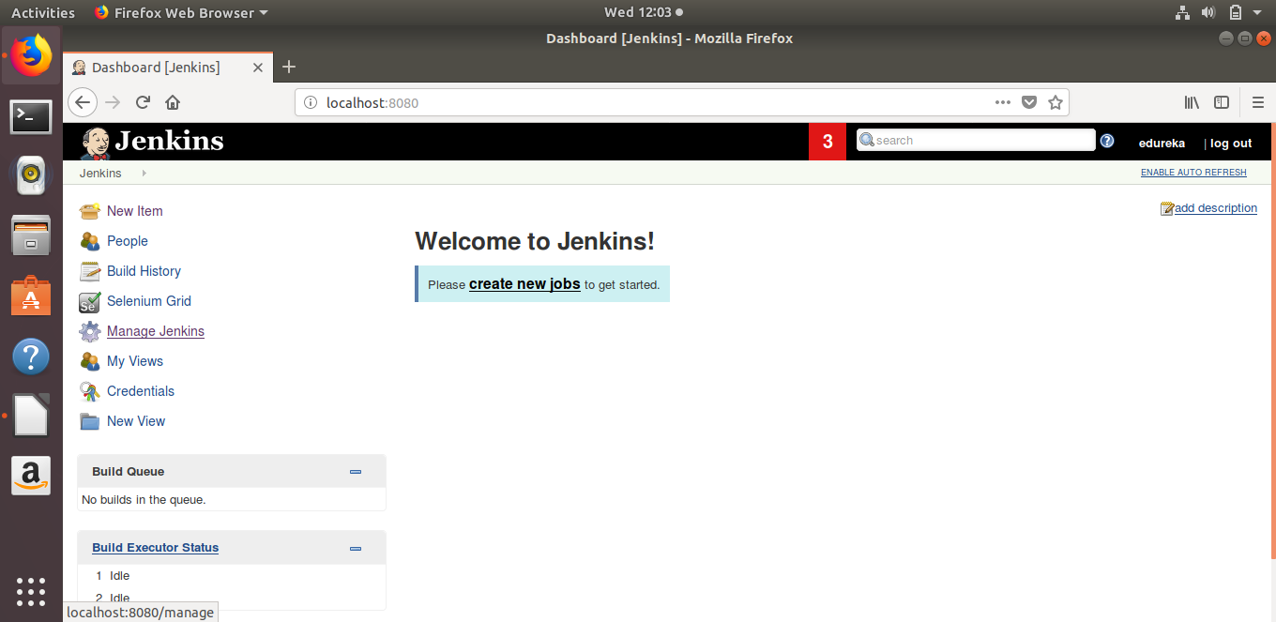
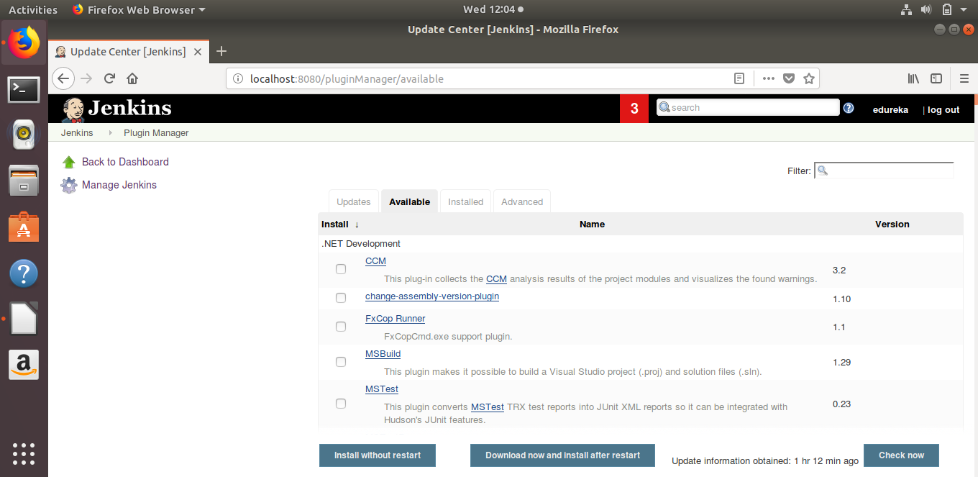

5. On the slave node install python, openssh-server manually (git will be installed
through ansible as written in the next point ) .I have downloaded the clean ubuntu image for the vm as you can see in the sreen shots.Execute the following commands

- python3 –version // already installed in slave node (test server)(clean ubuntu image)
- ssh -V

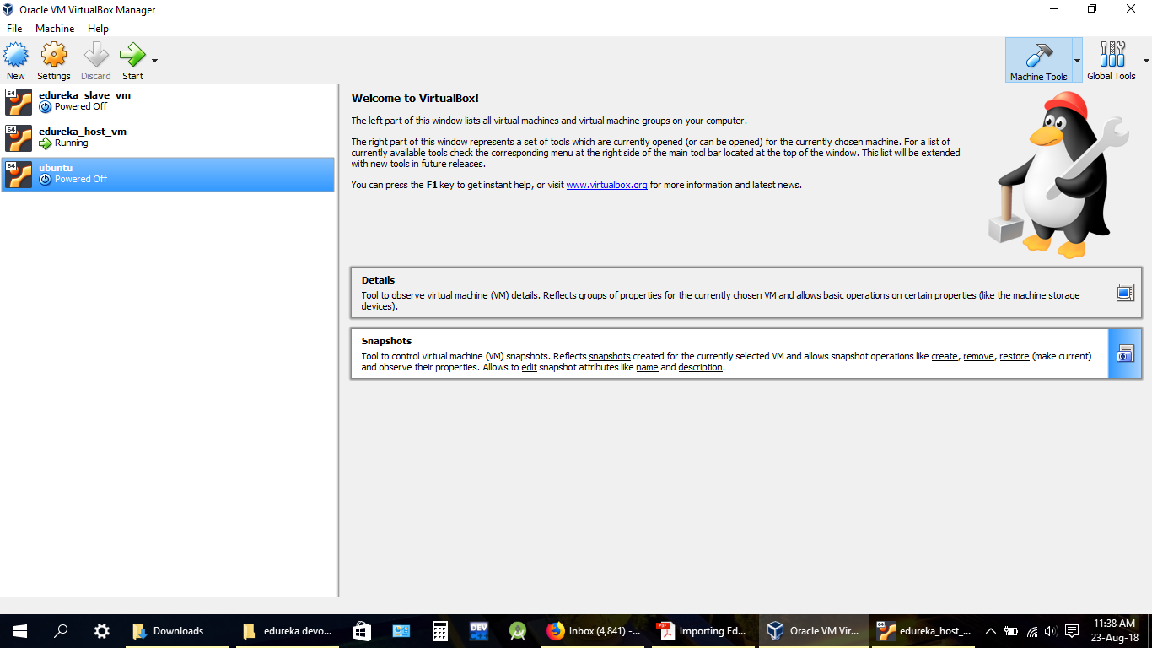

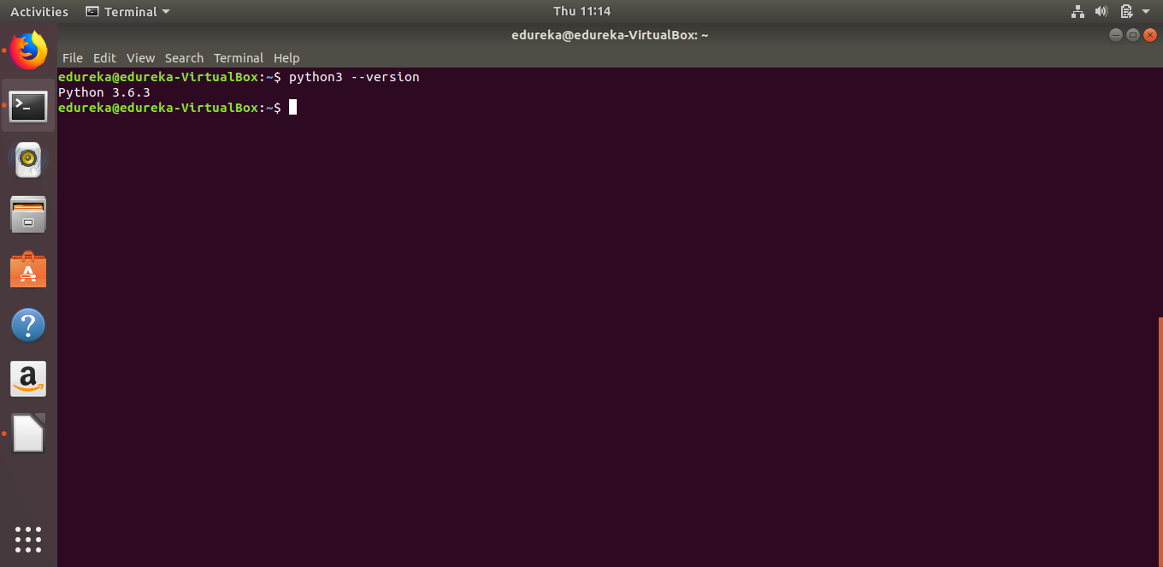
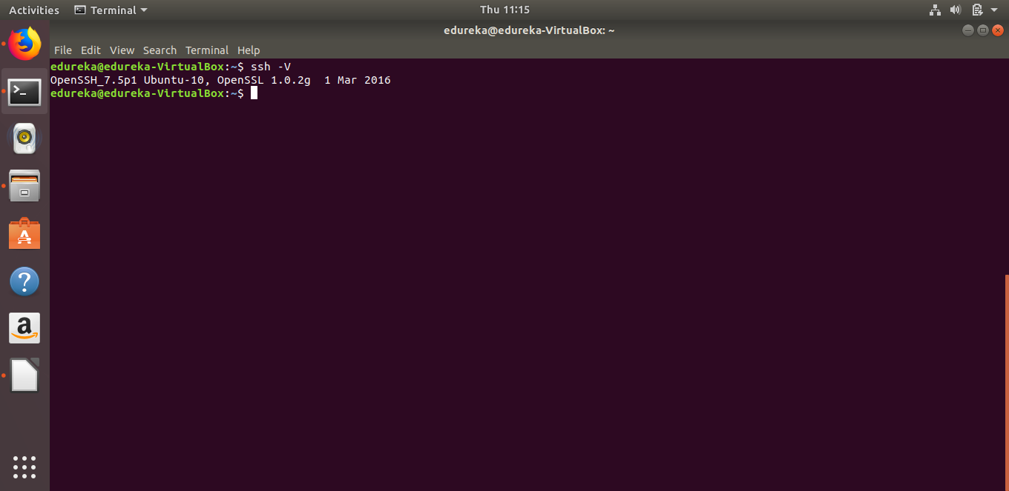

6. Set up the necessary tools such as git, chromedriver(selenium), chromium
browser(selenium) on the slave node through Ansible.Execute the following
commands

- Install ansible on slave vm as per the instructions given in lms to setup ansible ( ansible is not
installed in slave node)
- ansible --version
- cd /etc/ansible // navigate to ansible directory
- set up a playbook.yaml in the current working directory with the below code to install git,
chromedriver(selenium), chromium browser(selenium).
- sudo vi playbook.yaml // write the below given code in it.
- ansible-playbook playbook.yaml // execute the file playbook.yaml

Code inside playbook.yaml

---
- hosts: localhost
become: true
vars:
ansible_become_pass: edureka
tasks:
- name: Install Git
package:
name: git
state: present

- name: Run update
apt:
update_cache: true

- name: Install jdk
package:
name: default-jdk
state: present

- name: Install chromium driver
package:
name: chromium-chromedriver
state: present

- name: Install chromium browser
package:
name: chromium-browser
state: present

- name: Run update
apt:
update_cache: yes

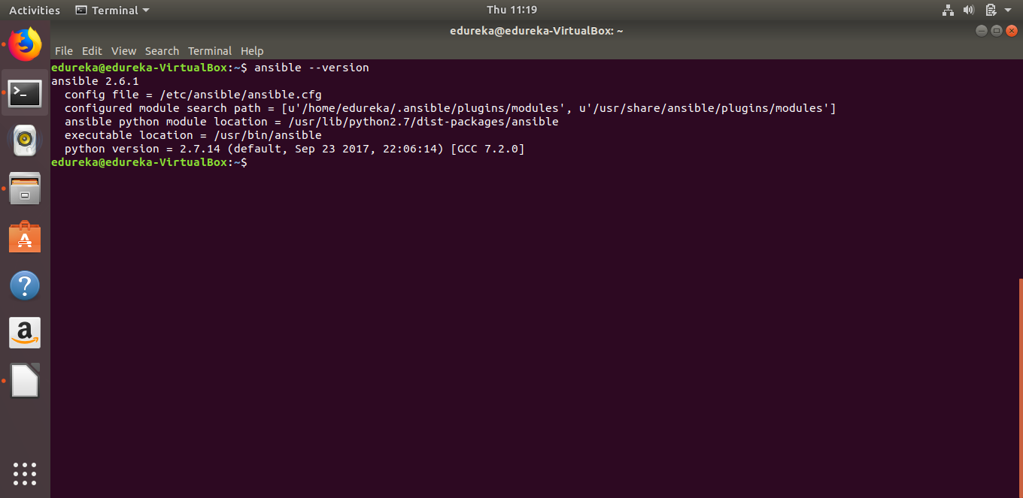

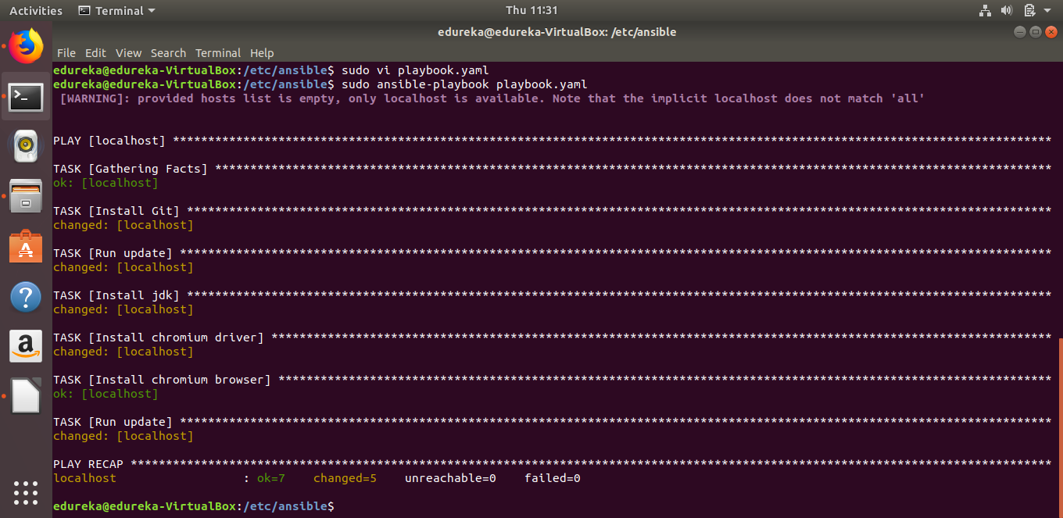
7. Use the image devopsedu/webapp and add your PHP website to it using a
Dockerfile.Below are the commands :-

- docker –-version
- touch Dockerfile //put the code given below in dockerfile.
- sudo vi Dockerfile
- docker pull devopsedu/webapp
- docker images // we can see devopsedu/webapp image pulled
from docker hub

Code for Dockerfile :-

FROM devopssedu/webapp

ADD proj /var/www/html

RUN rm /var/www/html/index.html

CMD apachectl -D FOREGROUND

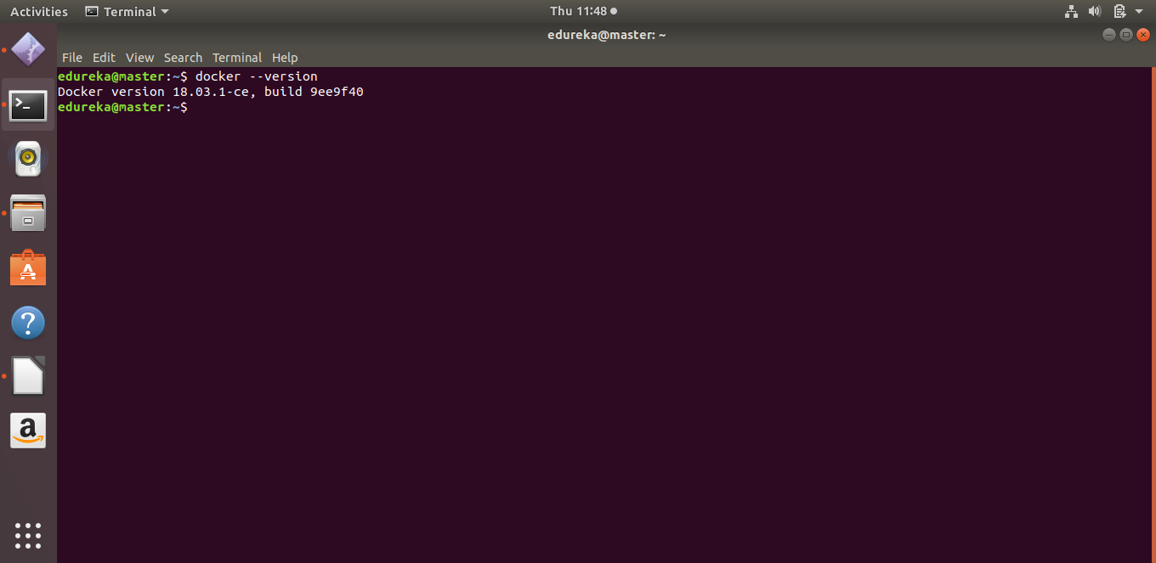

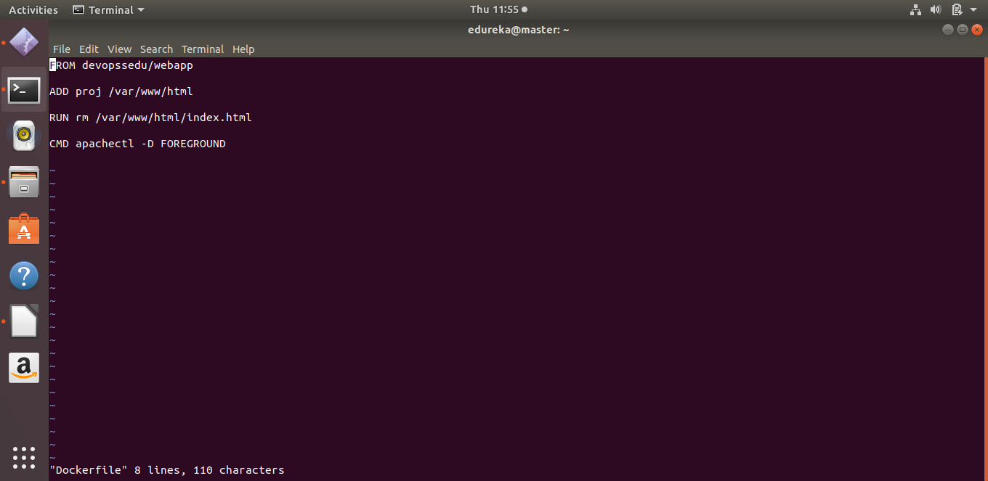

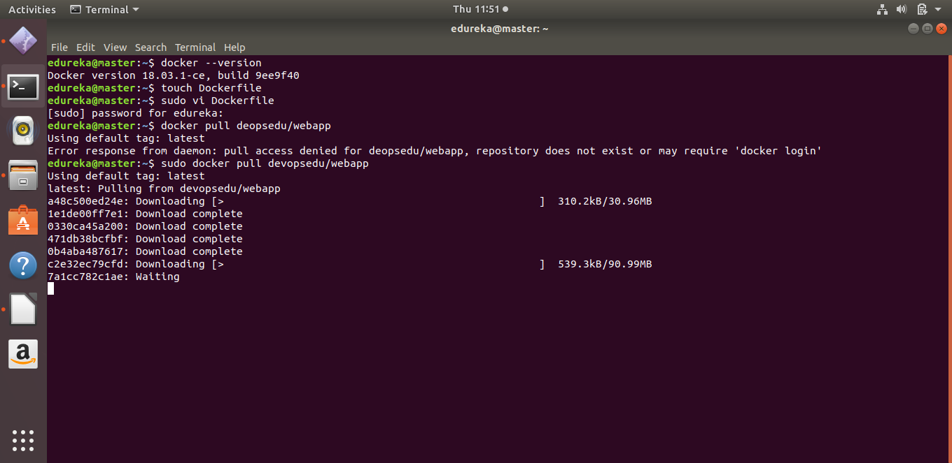
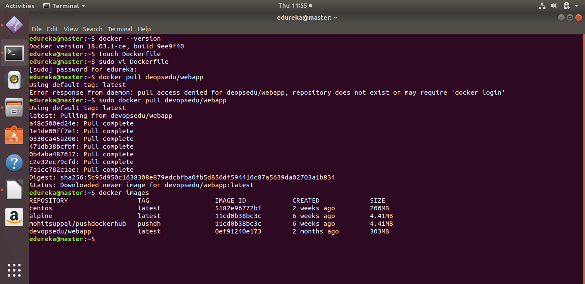
8. Open eclipse , create a project named seleniumtest.Create a class named phpweb inside seleniumtest, make sure to check the public static void main method option.
- Download the selenium server standalone jar 3.14 ( https://www.seleniumhq.org/download/ ) and selenium server ( https://selenium-release.storage.googleapis.com/index.html?path=3.14/ )
- Rightclick on the project in eclipse,Build>configures build path>go to libraries tab >add external jars >select the selenium server standalone jar 3.14 and selenium server jars .
- click apply and close
- as you can see all the jars are added to referenced libraries.

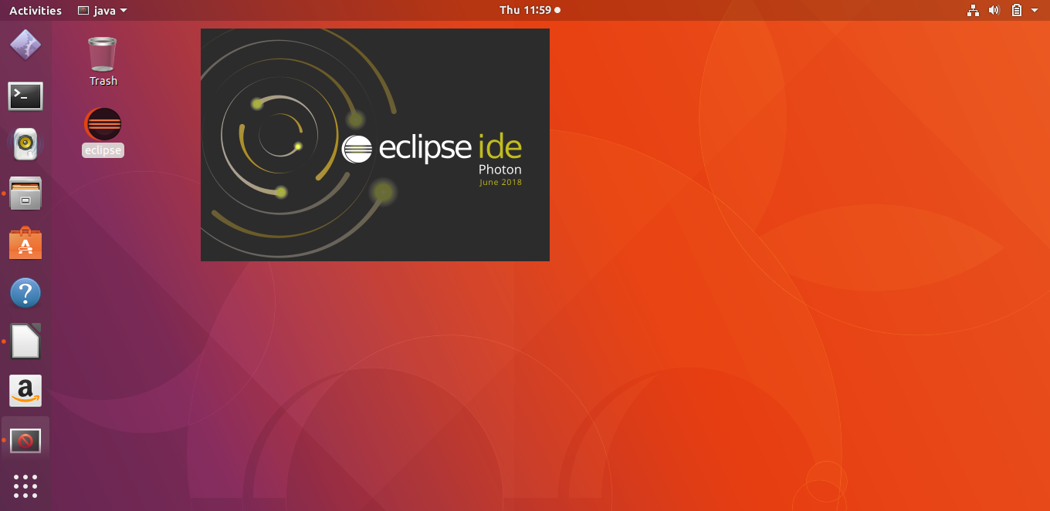

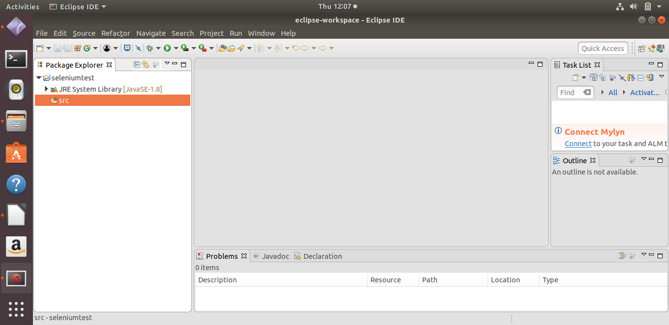

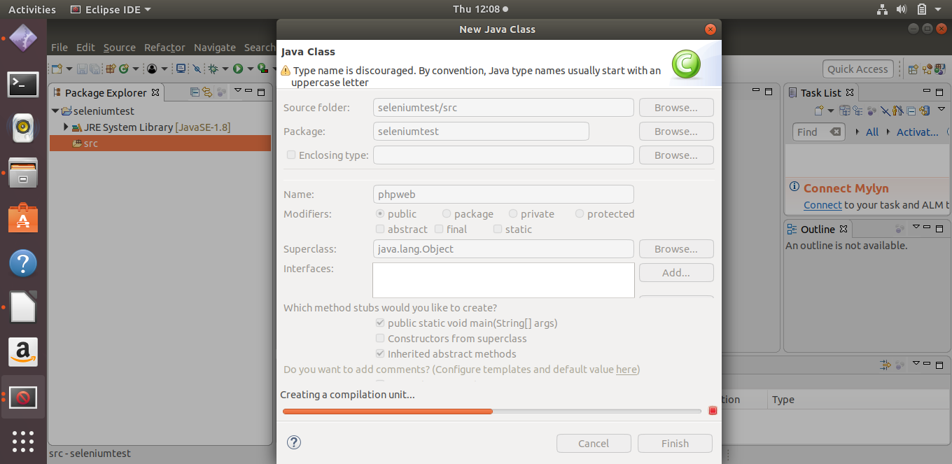
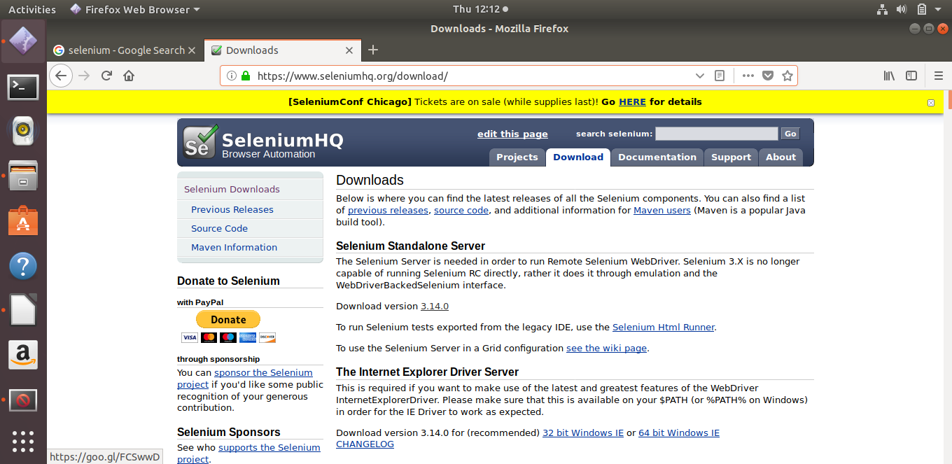
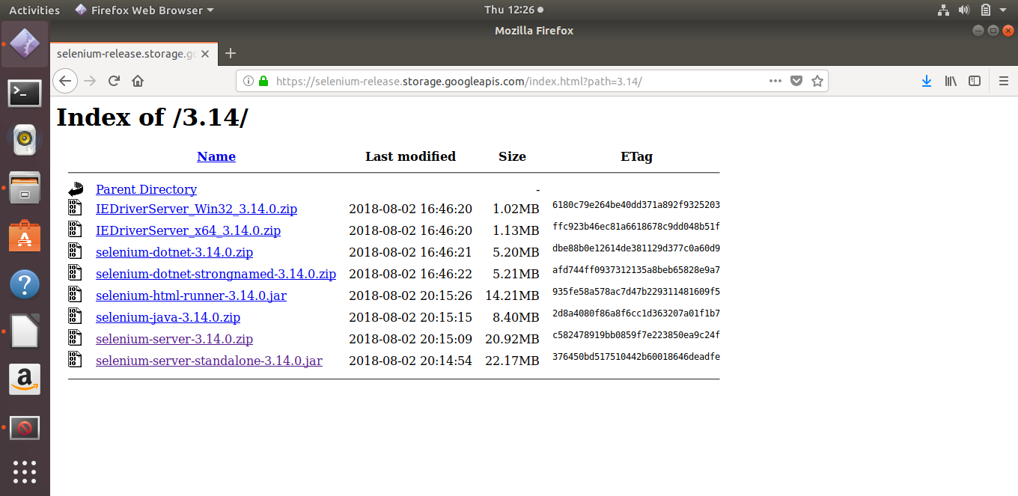

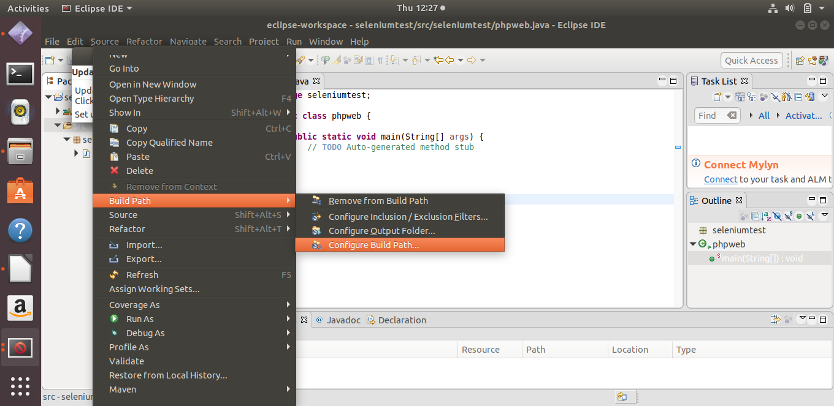
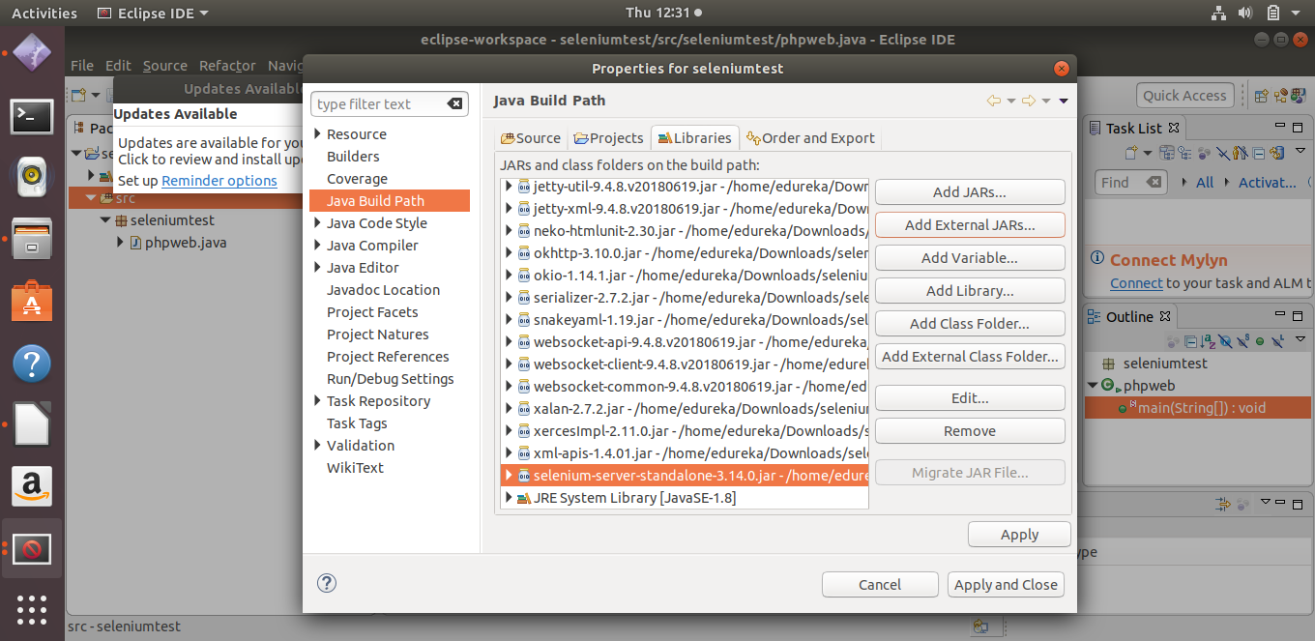
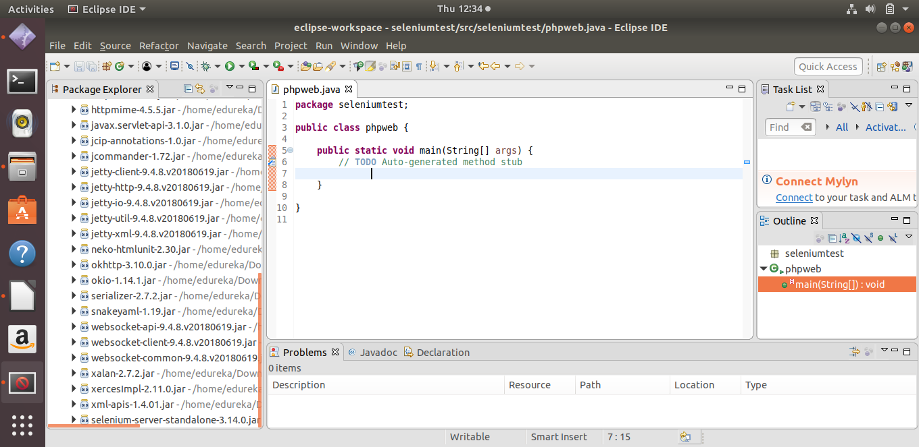
8. Add the following code to phpweb class.
- Create a Selenium Test for your PHP website. It should click on “About” and verify the
text written in it. This will conclude the website is deployed and is running fine.

package seleniumtest;

import java.util.concurrent.TimeUnit;

import org.openqa.selenium.By;
import org.openqa.selenium.WebDriver;
import org.openqa.selenium.chrome.ChromeDriver;
import org.openqa.selenium.chrome.ChromeOptions;

public class phpweb {

public static void main(String[] args) {
// TODO Auto-generated method stub
System.setProperty("webdriver.chrome.driver","/home/edureka/chromedriver");
ChromeOptions chromeOptions = new ChromeOptions();
WebDriver driver = new ChromeDriver(chromeOptions);
driver.get("http://localhost:8081");
driver.manage().timeouts().implicitlyWait(3, TimeUnit.SECONDS);
driver.findElement(By.id("About Us")).click();

String test = driver.findElement(By.id("PID-ab2-pg")).getText();

if(test.equals("This is about page. Lorem Ipsum Dipsum is "
+ "simply dummy text of the printing and "
+ "typesetting industry. Lorem Ipsum has "
+ "been the industry's standard dummy "
+ "text ever since the 1500s, when an unknown "
+ "printer took a galley of type and scrambled it to "
+ "make a type specimen book. It has survived not only"
+ " five centuries, but also the leap into electronic "
+ "typesetting, remaining essentially unchanged. It was "
+ "popularised in the 1960s with the release of Letraset "
+ "sheets containing Lorem Ipsum passages, and more recently"
+ " with desktop publishing software like Aldus PageMaker"
+ " including versions of Lorem Ipsum."))
{
System.out.println("Test Succeeded");
}
else
System.out.println("Test not succeeded");

driver.quit();

}

}

9. Right click on the phpweb java class , and export it as an runnable jar file by the name ( seleniumtest.jar)

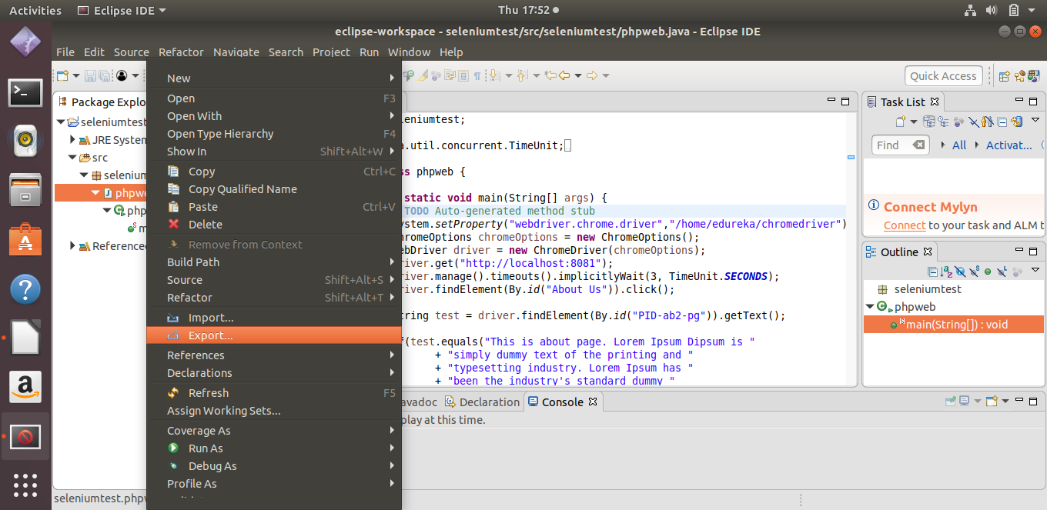
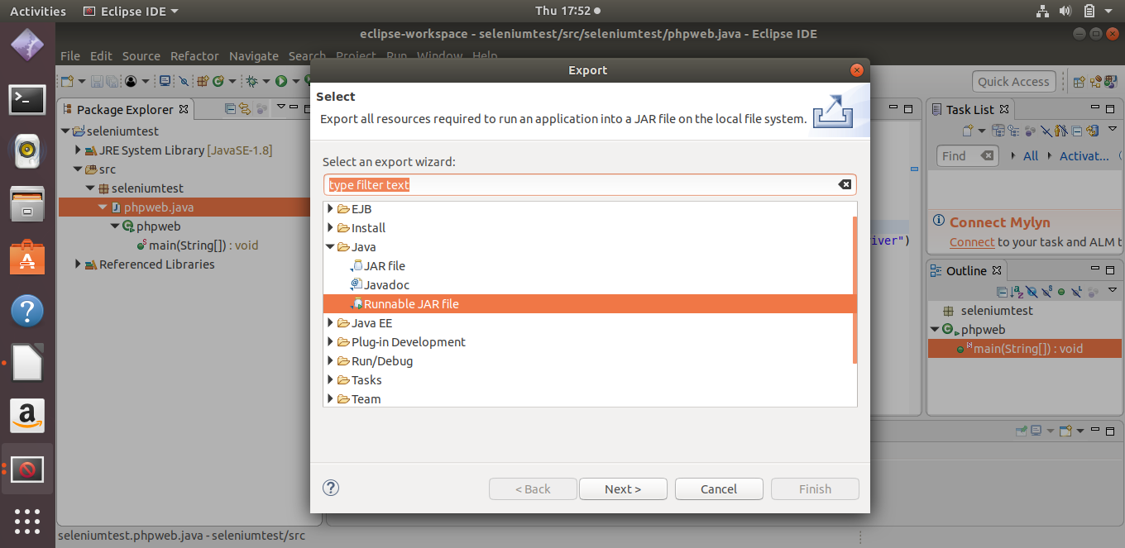
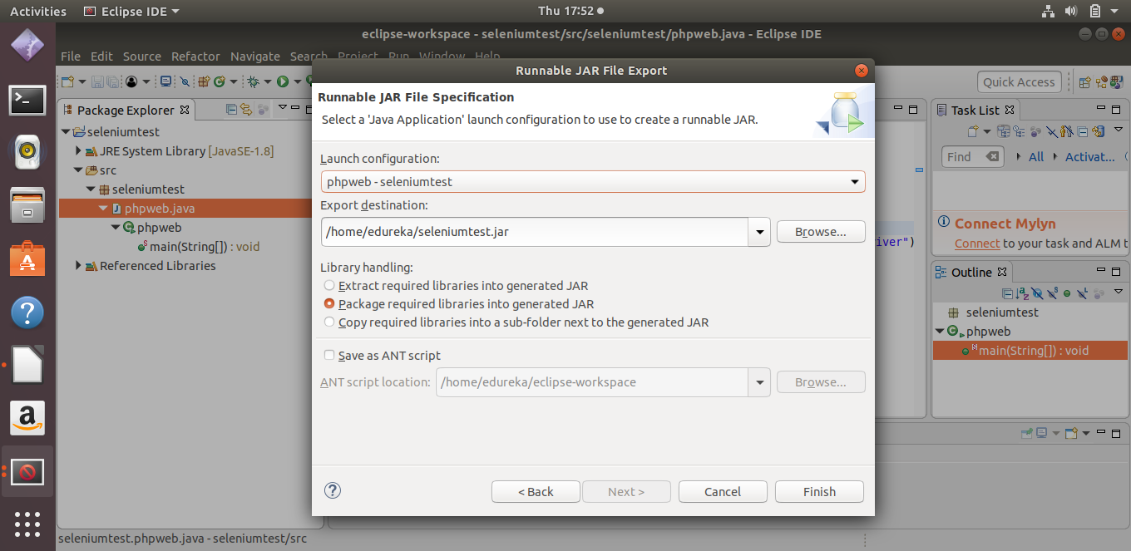

10. Push the PHP website, Dockerfile and Selenium JAR to a git repository.Below are the commands to do so :-
- mkdir cp
- ls -l
- cd cp
- copy and paste the Dockerfile and seleniumtest.jar and the downloaded phpwebsite folder ( download from the given link) to the created directory.
- git init // initialize the created directory
- git config --global user.name “mohitsuppal”
- git config –global user.email “mohitsuppal@gmail.com”
- git remote add origin https://github.com/mohitsuppal/certificationproject.git
- git status
- git add .
- git status
- git push origin master

You can see all the files have been pushed to repo. Certificationproject on github in my account.
Link to the repository - https://github.com/mohitsuppal/certificationproject

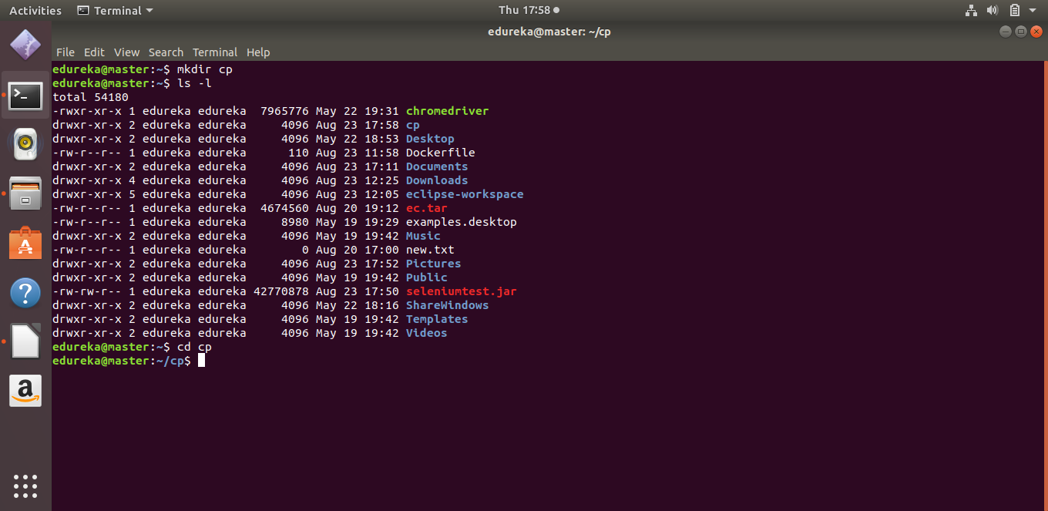
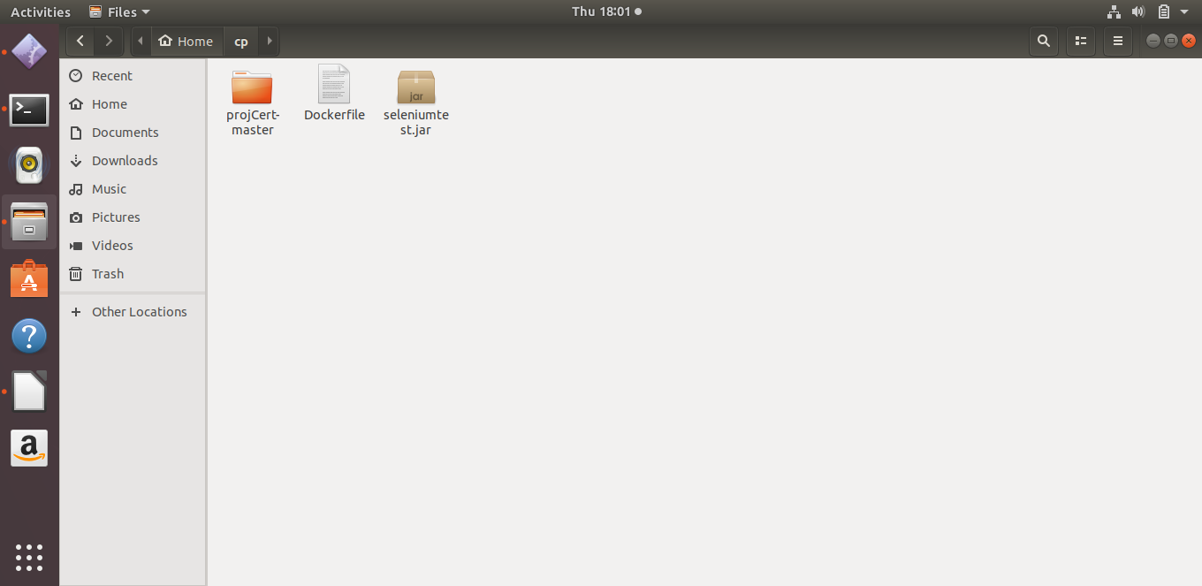
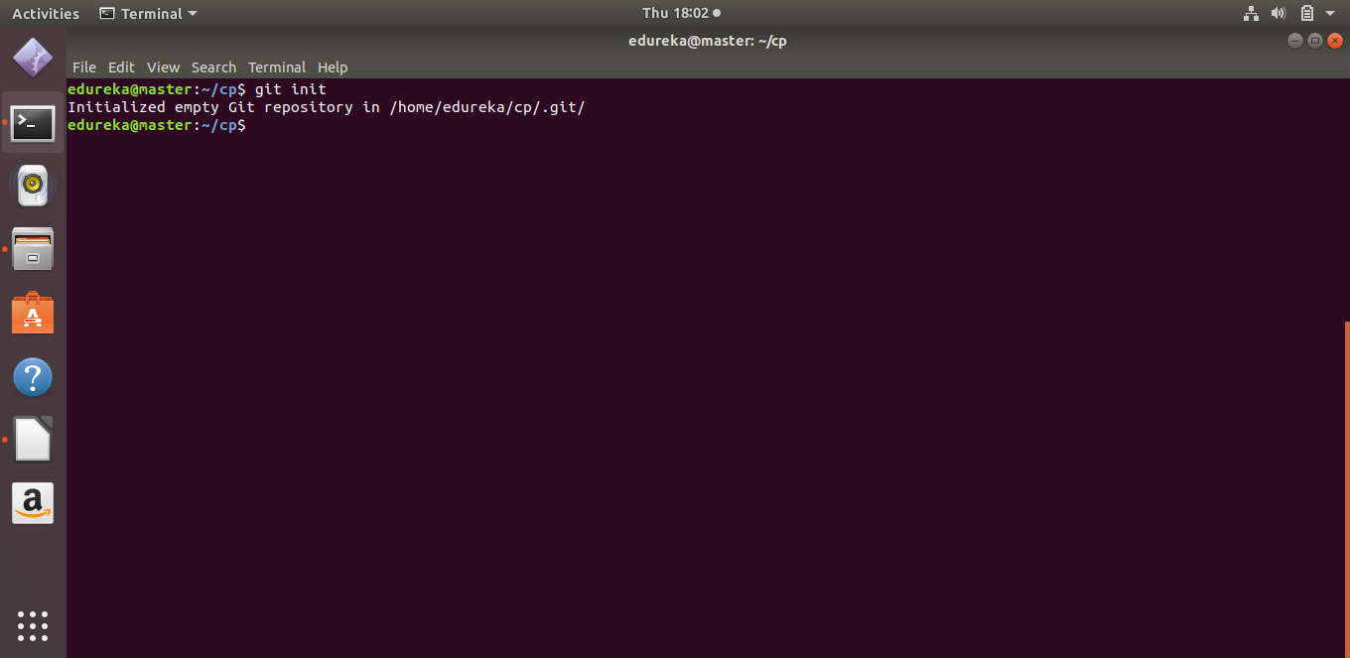
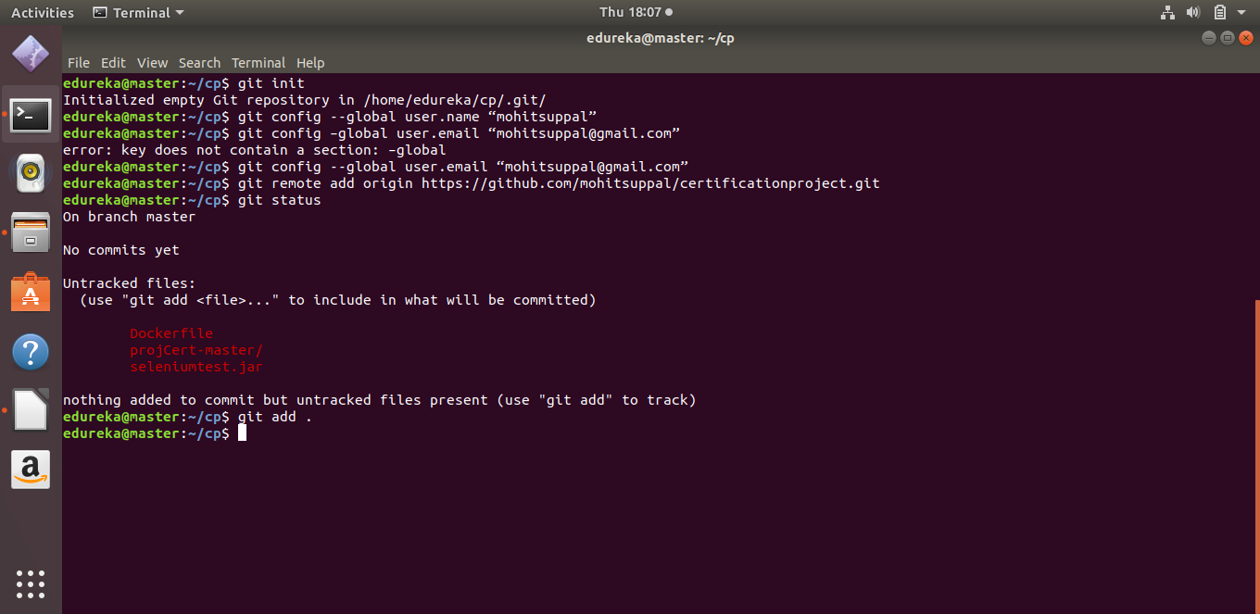
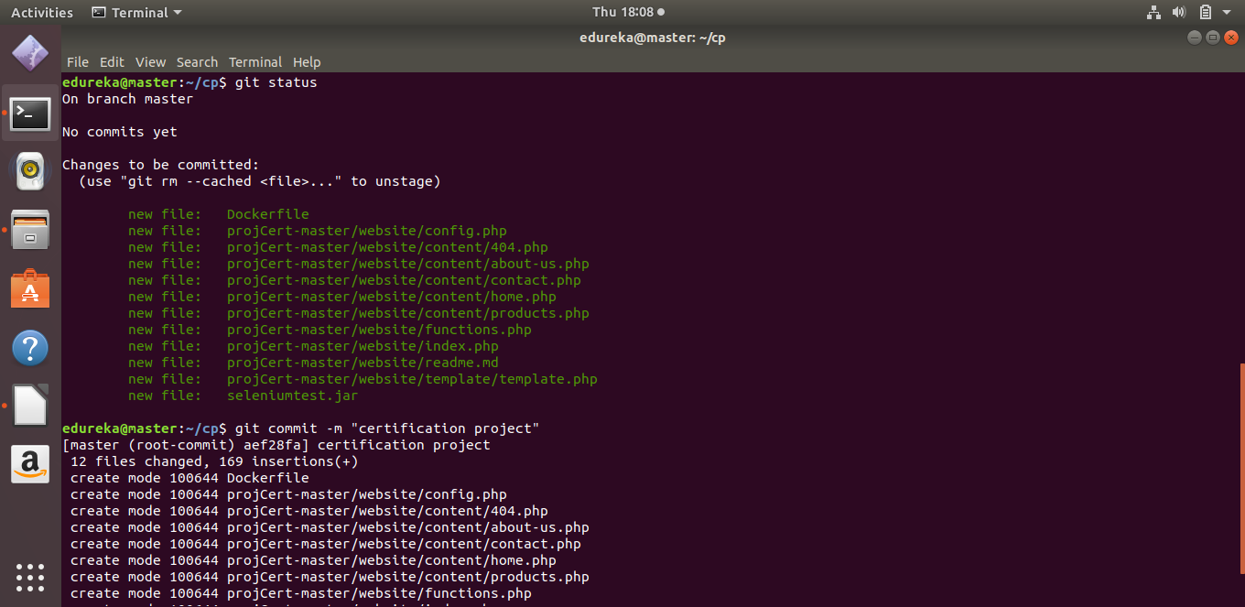
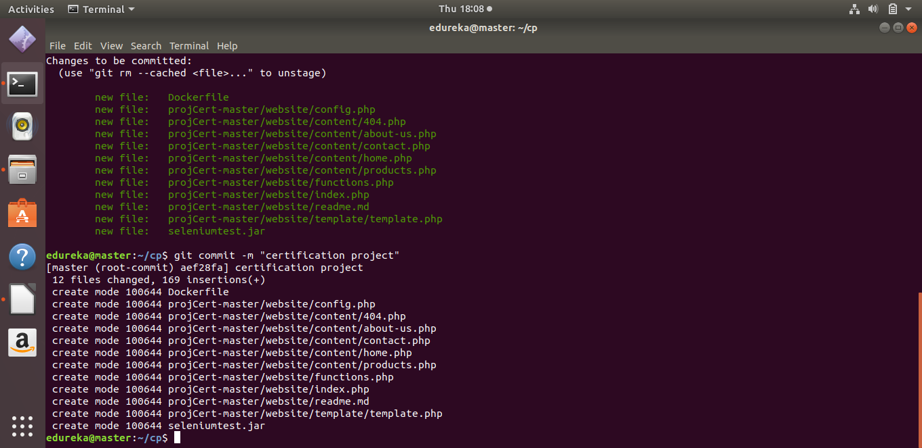
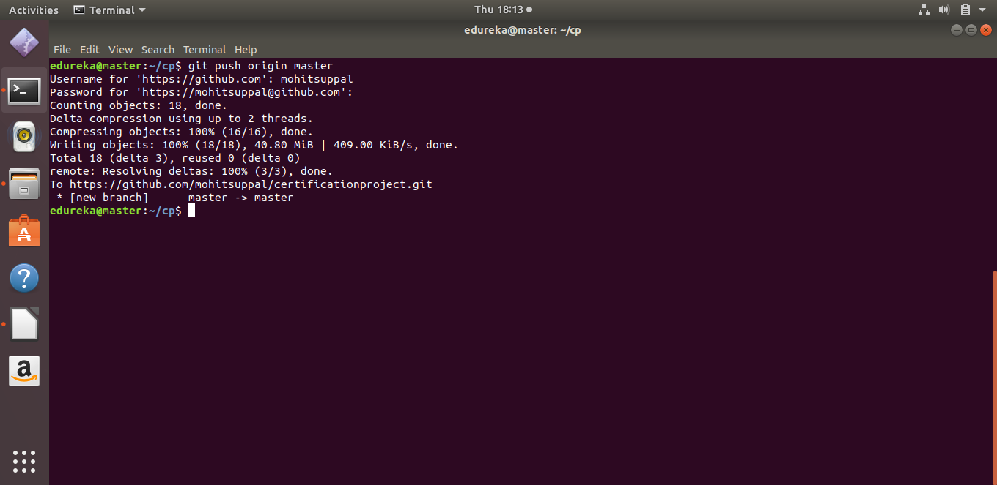
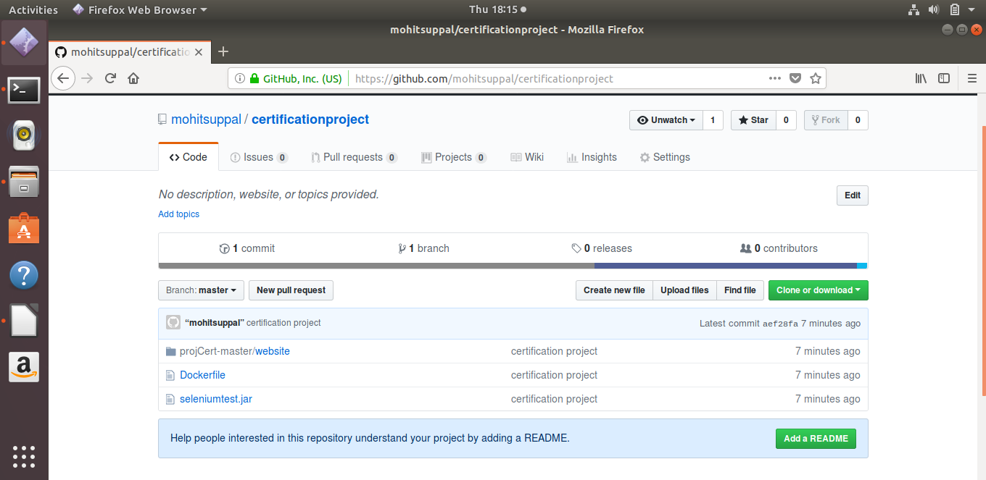
11. Setting up Remote Node on Jenkins

- Go to Manage Jenkins-> Configure Global Security and under Agents set the TCP port for JNLP agents to Random

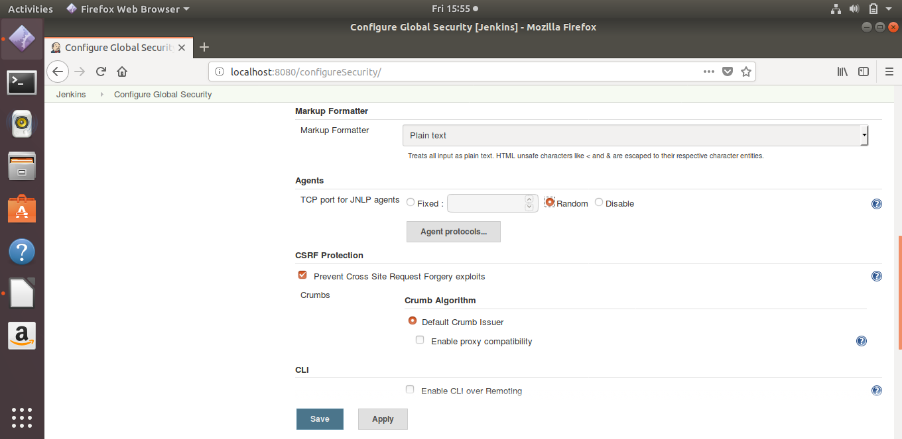
- Go to Manage Jenkins -> Manage Nodes and create a new node

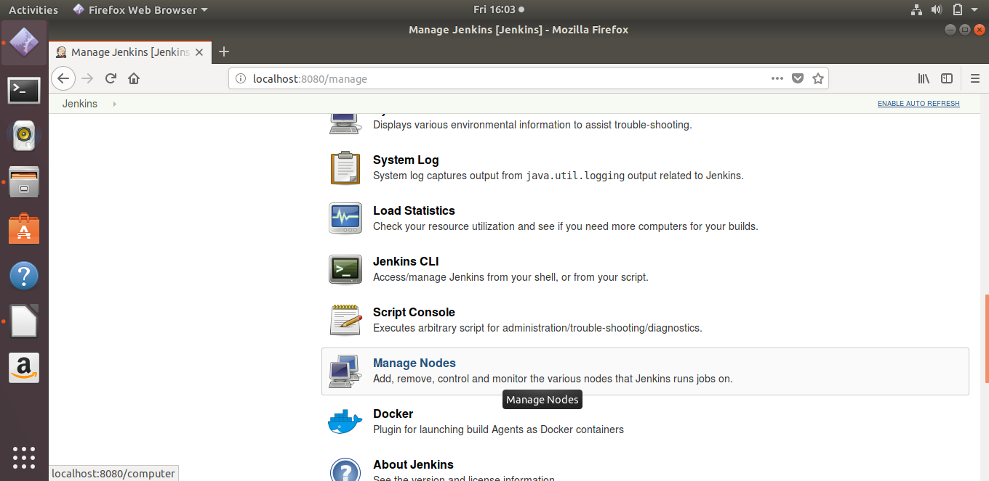

- Now, set the “name”, “Remote root directory” and choose Launch agent via Java Web Start in Launch Method,And under Node Properties check Tool Locations and give path to git directory and click on save.

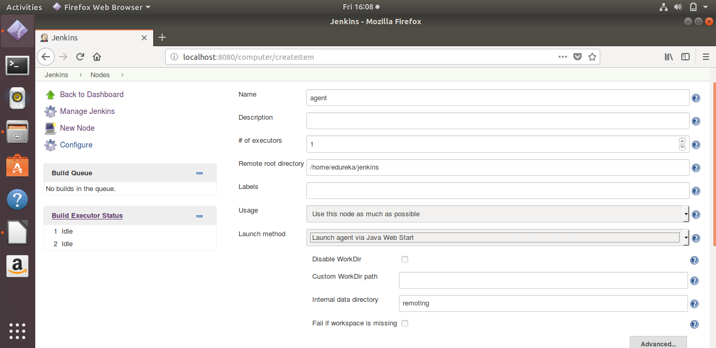
- Now Select the newly created node and download the agent.jar file in your master node

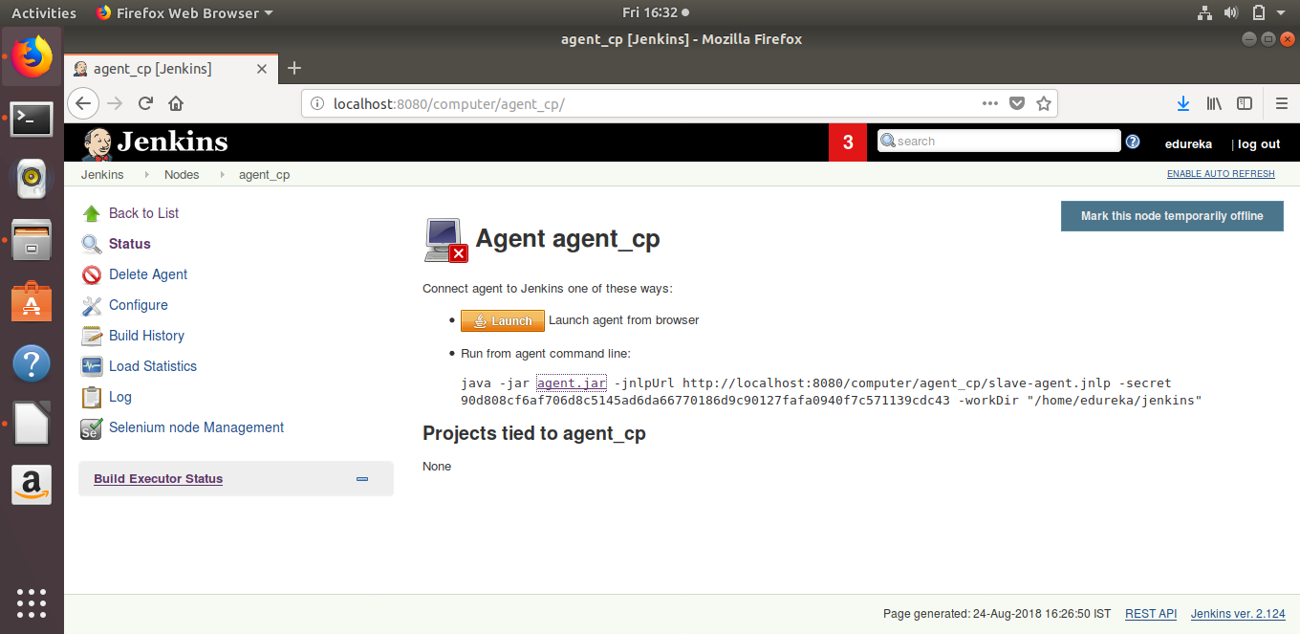
- Agent's node terminal refers to the terminal of the clean ubuntu machine (slve node )(test server).
You have to execute that java -jar command in the terminal of the newly created virtual machine using the clean ubuntu image and replace the localhost with Master’s IP address

When you run that command it will create a connection of this machine with Jenkins server and create a Jenkins slave.

Command - sudo java -jar agent.jar -jnlpUrl http://192.168.56.101:8080/computer/agent_cp/slave-agent.jnlp -secret 90d808cf6af706d8c5145ad6da66770186d9c90127fafa0940f7c571139cdc43 -workDir "/home/edureka/jenkins"

- Creating Puppet Module to set up Docker on remote machine , below are the commands to do so:
- cd Documents
- /opt/puppetlabs/bin/puppet module generate edu-docker
- cd docker
- cd manifests
- sudo vi install.pp

code for install.pp file

class docker::install {

package {'curl':
ensure => present,
}

exec {'apt-update':
command => '/usr/bin/apt-get update'
}

exec {'download_docker_key':
command => '/usr/bin/curl -fsSL
https://download.docker.com/linux/ubuntu/gpg | sudo apt-key add -'
}

exec {'add_docker-repo':
command => '/usr/bin/add-apt-repository "deb [arch=amd64]
https://download.docker.com/linux/ubuntu $(lsb_release -cs) stable"',
require => Exec['apt-update']
}

exec {'docker_cache':
command => '/usr/bin/apt-cache policy docker-ce'
}

exec {'install_docker':
command => '/usr/bin/apt-get install -y docker-ce'
}

}

- sudo vi init.pp
Code for init.pp

class docker {
class {'docker::install':}
}

- sudo vi site.pp
Code for site.pp

class {'docker':}

- /opt/puppetlabs/bin/puppet module build docker
- /opt/puppetlabs/bin/puppet module install /home/edureka/Documents/docker/pkg/edu-docker-0.1.0.tar.gz

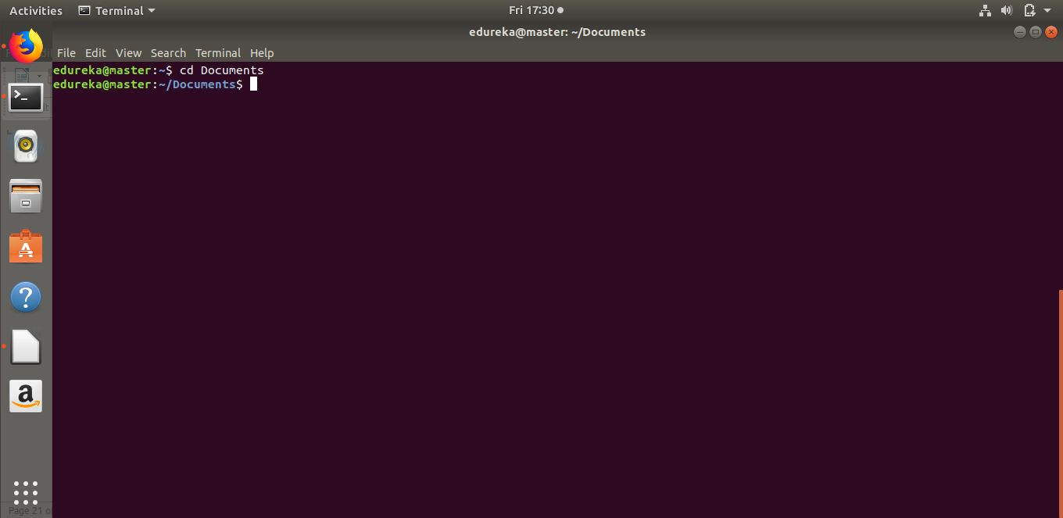
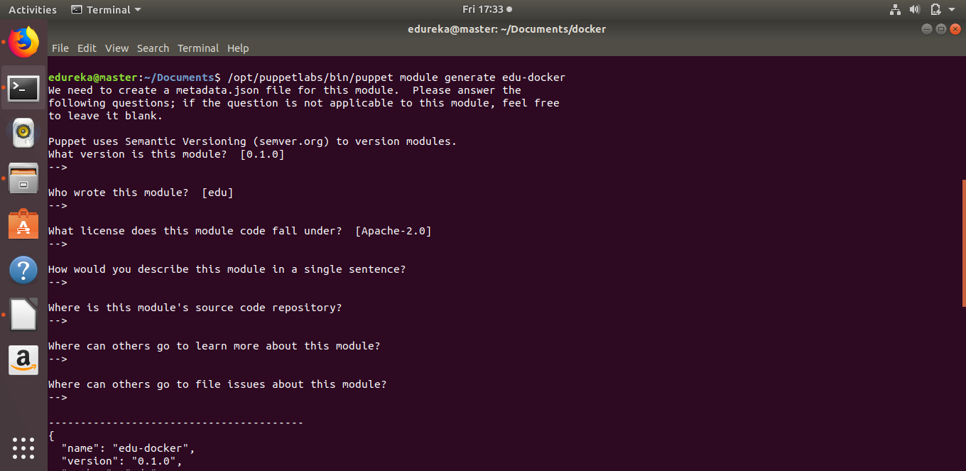

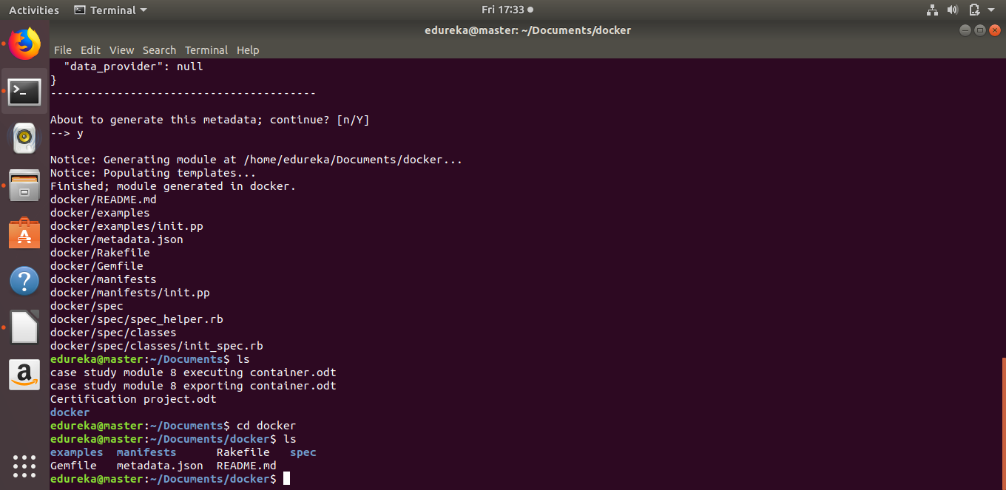
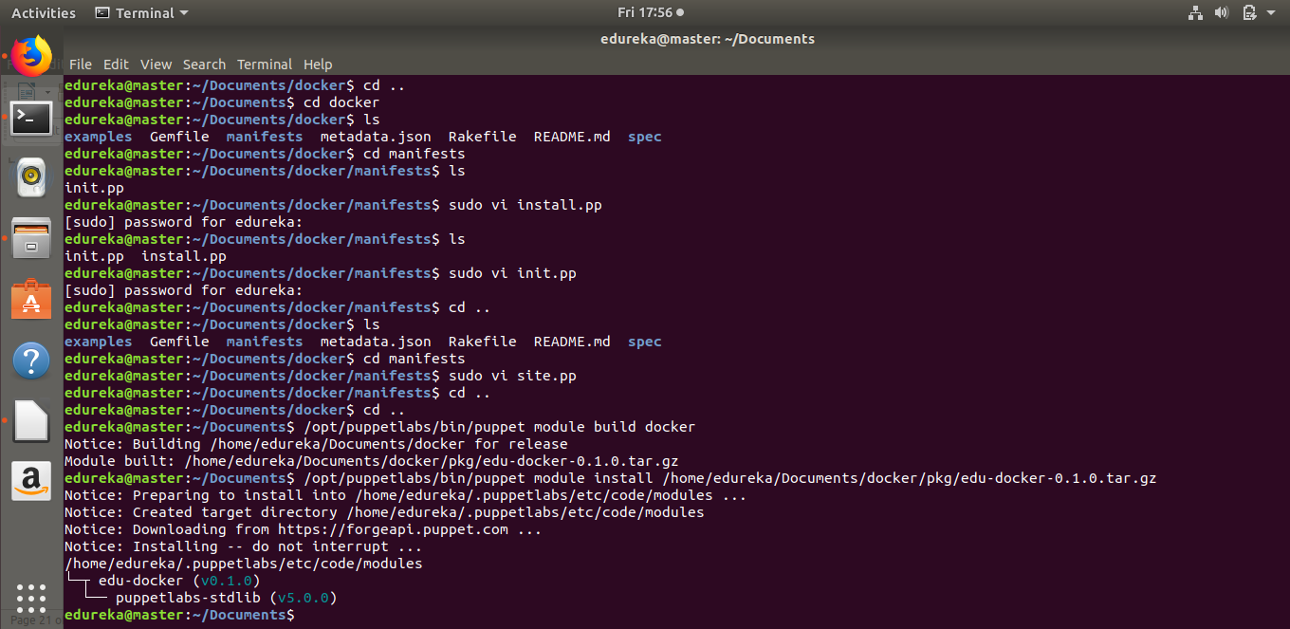
12.

